College Hill Community Church Announcements!
01/23/2022
The Pathways to Home Ownership Project 2022
Week of Compassion, the disaster ministry of the Christian Church (Disciples of Christ), will be hosting volunteers to finish the interiors of homes as part of this project January 9 - April 2, 2022. COVID protocols in place
TEAMS:
- 4-10 people & 14 years of age or older
WORK & SKILLS:
- Teams should commit to a minimum of 3 days of work per week; most teams work Monday-Friday
- All skill levels are welcome!
- Tools will be provided
HOUSING:
- A housing site is available at a local church, if needed
- $50/person/week to cover building use and utility costs
For more information or to register:
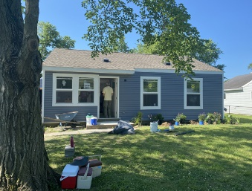
Email Caroline Hamilton-Arnold at caroline@weekofcompassion.org
The new secretary office hours are as follows: *Phones are answered 9-3pm daily*
Monday: 9-2:30pm @Home Tuesday: 9-2:30pm in Office Wednesday: 9-2:30pm in Office Thursday Hybrid: 9-12 @Home 12:30-3 in Office Friday: 9-2:30pm @Home
You can now give electronically on Faithlife! There are 3 different ways to give:
- Go to faithlife.com and search College Hill Community Church.
- Text the word “Give” and the amount to 937-230-6530.
- Download the app and search for College Hill and verify the address 1547 Philadelphia Dr.

Church emails:
Office Phone Number: 937-278-4203
*If you have any announcement throughout the week, please email the secretary so updates can be shown here! *
pastor@collegehillcommunitychurch.org
secretary@collegehillcommunitychurch.org

FREE COVID TESTS FOR EACH HOUSEHOULD NOW AVAILABLE ONLINE! NO CREDIT CARD NEEDED. 1 SET OF 4 PER HOUSEHOLD.
www.covidtest.gov
Race, Science, and the Church
The “Race, Science, and the Church” Zoom workshop will be held on February 16 and 23 from 12:00 - 1:30 P.M. both days.
Journey Groups
This is an opportunity for teaching elders and commissioned ruling elders to participate in Journey Groups, small groups to encourage support and resilience, facilitated by LeaderWise psychologists. The groups meet monthly from March to November. Deadline to sign up is February 15.

MLK DAY

