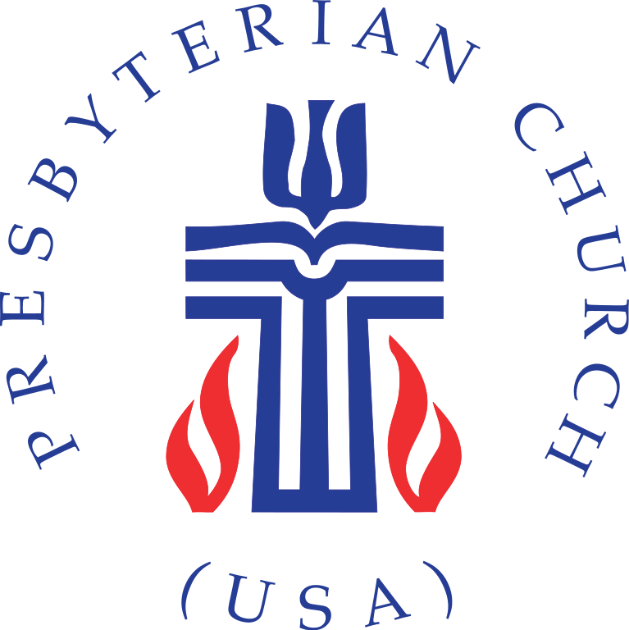College Hill Community Church
July 2023 Newsletter
PHONE: 937-278-4203 ● FAX 937-278-2606
EMAIL: collegehillcommunitychurch@gmail.com
WEB SITE: www.collegehillcommunitychurch.org
SUNDAY WORSHIP SERVICE AT 10:30 AM (Bilingual Worship) and on College Hill Community Church’s Facebook Page.
ADULT SUNDAY SCHOOL CLASS 9:15 AM ON ZOOM Please check our Facebook page for Sunday’s Zoom link until further notice
JULY CHURCH CALENDAR
July 2 – Prayer Service. Communion Sunday. Immigration Sunday. Also, we invite you to wear red, white and/or blue in observance of Independence Day.
9 - Rev. Charles Tinsley Matthew 11:16-19, 25-30 Sermon Title: "Take my yoke upon you, and learn..."
16 - Rev. Charles Tinsley Matthew 13:1-9, 18-23 Sermon Title: "They had no root, they withered away.
23 - Rev. Charles Tinsely Romans 8:12-25 Sermon Title: "For who hopes for what is seen?"
30 - Edgar Sánchez Cruz, Camp Wakonda

GREETINGS AND INFORMATION FROM THE PCUSA AC
June 29, 2023
Dear siblings in Christ.
The Administrative Commission is trying to do what we can to provide some stability in this time of very rapid change for College Hill Community Church. We know that you have questions, feelings, and concerns, and we are trying to prioritize our own time. Please know that you are constantly in our prayers and we ask that you also pray for us.
The worship schedule for July is being finalized. On July 2, we are planning a prayer service. When times are difficult, it is often helpful to read Psalms and offer prayers. That is exactly what we plan for July 2. Music will be led by Calista Brunett who is the Music Resident at Westminster Presbyterian Church in Dayton.
Worship the following three Sundays (July 9, 16, & 23) will be led by Rev. Charles Tinsely. He is a retired pastor who recently served West Cincinnati Presbyterian Church. On July 30, Edgar Sánchez Cruz will preach. He is a summer camp counselor from Camp Wakonda.
Our next priorities are to ensure office coverage and coverage of pastoral care during a time of transition.
We will have updates on mediation and elder training following our next session meeting on July 12 at 6:00 p.m.
In our review of items previously on the session agenda, we decided to re-key the building because of the confusion about who has keys. The church will be re-keyed on June 30.
Please feel free to contact us at collegehillac@gmail.com
Grace and peace,
Elder Donna Courtney
Elder Bridget Hawkins, Clerk of Administrative Commission
Rev. Lucinda Isaacs, Moderator of Administrative Commission
Rev. Cynthia Holder Rich
Elder Gene Saunders, Clerk of Session
Rev. Angie Schenck
CONTRIBUTION MESSAGE FROM OUR FINANCIAL SECRETARY
As of tomorrow, FaithLife will not be working. They have closed and now Servant Keeper is taking over. So, if you still want to give online to College Hill Community Church, you will still be able to donate.
Here is the official information:
Dear Donor,
College Hill Community Church has changed our giving tool to Servant Keeper as of July 1, 2023. This will provide all the same service that you have come to expect from your church, just with a new provider. You will notice that it even looks and works very similar to Faithlife Giving, our previous tool. Servant Keeper is experienced and provides highly secure transactions.
Questions about the new solution? Go to - https://giving-servantkeeper.com/chcc-dayton-oh. You will sign in with your Faithlife email address and your password. Then you will be asked to change your password and will get an email with a new password.
Please note that if you have a scheduled gift, it has been saved and will continue as it has previously. However, if you have changed your payment method since March 1, please update it so we have the latest information. Soon, you will be able to make any changes to your scheduled gift directly in the Servant Keeper app.
We thank you for your continued support of our church community over the years.
If you have questions, please call me
Paula Ewers, Financial Secretary at College Hill Community Church
Contact Support at her email or phone number
ewersjt@yahoo.com 937-902-6508

COLLEGE HILL SCHOLARSHIPS AND YOUTH RECOGNITION
As we want to make sure all of our youth and families have received this information, we are extending the deadline for applying for the Elam Scholarship to 14 July 2023. There is a 200–500-word essay required as part of the application. In the essay, we want to know about your faith walk, your College Hill experience, and plans for your future. Please send emails/photos to cmestelle3@gmail.com. Applications are available in the church turnstile by the church office and online.
Recognition Sunday is July 23, so please send any celebrations your youth and you have had this past school year by the July 14 deadline. Have you been promoted to 1st grade, or to a new job? Have you received an award or honor? Let your College Hill family celebrate with you! Please send your celebrations to cmestelle3@gmail.com.
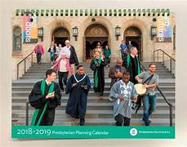Discounts for Presbyterian Planning Calendars—Order Now!
The annual Presbyterian Planning Calendar is a great way to learn about the exciting ministries of the national Presbyterian Church (U.S.A.), find key Scripture passages and liturgical colors for each Sunday, plan for special events and offerings, and have contact information for key national and regional staff who work for us everyday thanks to our per capita fund payments.
The 2023-2024 Planning Calendar runs from September 2023 to December 2024. Bellbrook Presbyterian Church is graciously coordinating a special order of Planning Calendars for churches at the greatly reduced rate of $9.75 per calendar (a $7.00 savings!). Larry Hollar is collecting the orders for College Hill members to get this discount price. You must send Larry your order by email or phone by Tuesday, July 4, to get the special rate (he submits the order on the final possible day of July 5). Call Larry at 937-643-3168 or email him at larryhollar@gmail.com, specifying how many calendars you want at the $9.75 price. Don’t delay! He will work out delivery and payment plans when the calendars arrive.

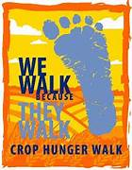SUPPORT THE DAY CROP HUNGER WALK ON SUNDAY, OCTOBER 8
This year’s Dayton Area CROP Hunger Walk will again be at Shiloh UCC Church in Dayton on the early afternoon of Sunday, October 8, 2023. This annual Walk raises funds for both Church World Service and the Dayton Foodbank to combat hunger and poverty at home and abroad. College Hill has the proud reputation--set over many years--of raising the most funds of any Dayton-area faith community taking part in the Walk. Let’s do it again this year! Even though the Walk is in October, you can now sign up to be a walker for the College Hill team or provide online financial support to the team or to any walker at this link: www.crophungerwalk.org/daytonoh. Just click on the list of teams already registered and College Hill will appear. Watch for more details on the CROP Hunger Walk in future College Hill monthly newsletters. Larry Hollar (larryhollar@gmail.com) is again coordinating our church’s team.

ELAM PR MINISTRY PREPARES FOR ANNUAL FLEA MARKET
The annual Elam PR Ministry Flea Market will be Saturday, August 5, from 10am to 4pm. Vendors may reserve a space beginning July 1st by calling Co-Chair Krista Lewis at 937-613-2140. Spaces are $30. Money will be collected at the church on July 6, 9, 13, 16, and 23. Items to sell may also be donated to College Hill’s Outreach table with the profits being donated to a community project. Contact Kathy Lakes for drop off or pick up donated items. Finally, we invite you and your friends to come shop and meet your community family on Saturday, August 5!
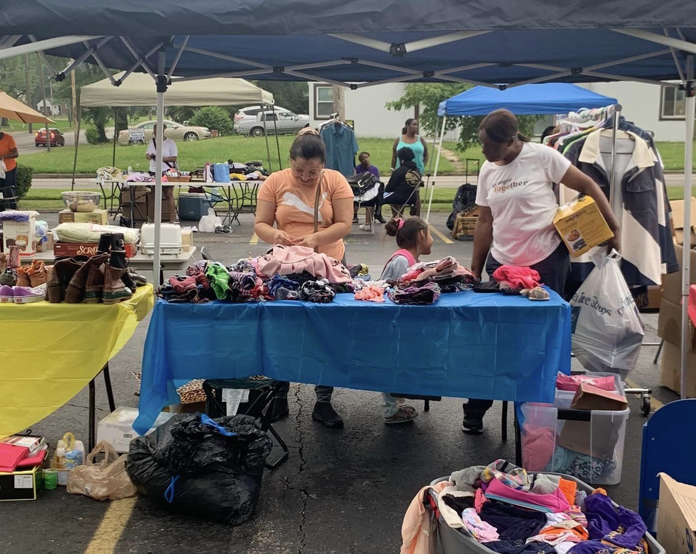

4th of July-What’s love got to do with it?

May was Pacific Asian American Month. June has Juneteenth a National Holiday for the very first time as well as a focus upon Gay pride. In just over a week, we Americans will be celebrating the 4th of July. The proximity of these celebrations elicited some interesting thoughts for me. Due to their history and current lives, many people most closely involved with one or more of the first three events, have some reservations, or actual aversions, to recognizing the 4th of July. This is the point in which the title of this piece comes into play-at least for those of us who profess to be Christians.
As Christians, the answer to the question posed,” What’s love got to do with it?” is far different from the words of the popular song. For us love has something to do with everything and far from being a secondhand emotion is the most important thing of all. That knowledge does not change us into Pollyanna's, but instead provides a different filter or lens for us to deal with slights, mistreatments or injustices. Jesus doesn’t just tell us to “turn the other cheek”. In fact, God ‘s word tells us in many places, the following:
Micah 6:8 - He has told you, O mortal, what is good; and what does the Lord require of you but to do justice, and to love kindness, and to walk humbly with your God?
Mark 12:30-31 - Love the Lord your God with all your heart and with all your soul and with all your mind and with all your strength.’^{[a]} ³¹ The second is this: ‘Love your neighbor as yourself.’^{[b]} There is no commandment greater than these.”
Matthew 6:14 “For if you forgive other people when they sin against you, your heavenly Father will also forgive you.”
Proverbs 3:11-12 11 My son, do not despise the Lord’s discipline or be weary of his reproof, 12 for the Lord reproves him whom he loves, as a father the son in whom he delights.
So as Christian Americans or non-citizens living in America, love has everything to do with celebrating the 4th of July. Yes, America does have, and still has a regrettably tragic past and present in dealing with the various immigrant, enslaved person, or persons of different genders/sexual preferences. However, Christ’s claim on our lives impels us not to withdraw from 4th of July celebrations, but to remember the good of our country, embrace the loving principles on which our county was founded, recognize our failures, reprove that which is hypocritical in their practice and work together to make improvements.
All that being said, have a wonderful day with family and friends, or even by yourself. Remember “What’s love got to do with it?” Everything! (Submitted by co-editor Pat Townsel)

MEMORIAL SERVICE FOR RICHARD RIGHTER ON JULY 15
All are welcome. We had to delay the service, but we look forward to a time together on Saturday, July 15, 2pm with refreshments following at Westminster Presbyterian Church, Downtown Dayton, Ohio. Lisa Righter and Karen Righter Geiger
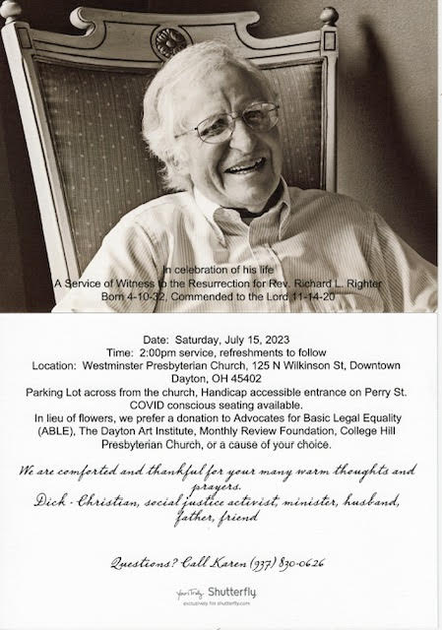

VACATION BIBLE SCHOOL - “I’ve Got This!”
This year’s VBS, partnering with Believer’s Christian Fellowship Church, was a huge success. As it says in 1 Corinthians 4-6: 4 There are different kinds of gifts, but the same Spirit distributes them. ⁵ There are different kinds of service, but the same Lord. ⁶ There are different kinds of working, but in all of them and in everyone it is the same God at work. Every evening 50-65 people fellowshipped together with scripture lessons, music, movement, craft and praising God! We thank the Presbyterian Women and Men’s groups for providing meals and their volunteer time. Thank you, Pat Townsel, for organizing the meals. We thank our volunteers from College Hill who helped teach, make crafts, and walked kids to and from their various classes. We especially thank Elder Brenda Brown who has helped coordinate VBS for many years. All of these “gifts” being shared made this week a success.
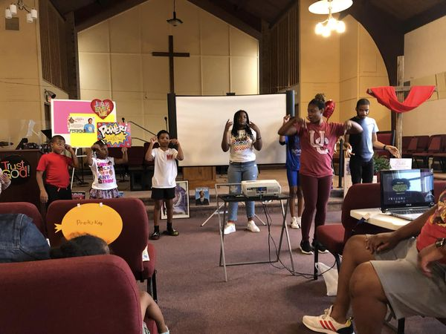
ETHEL SMITH HONORED ON JUNE 24th
On Saturday, June 24, long-time College Hill member, Ethel Smith, was honored at the Presidential Banquet Center by the Believers Christian Fellowship Church at their annual Recognition Banquet. Pastored by Rev. Dr. William E. Harris. Ethel was honored as the First Black Graduate of Good Samaritan Hospital’s School of Nursing; class of 1954. Her bio also included her living in Longtown, her uncle being DeSoto Bass, and her helping to begin Dixon Methodist Church. Also, she won the 2018 NAACP Community Outreach Award. Many family members and friends of Ethel were at the banquet in support of Ethel Smith.
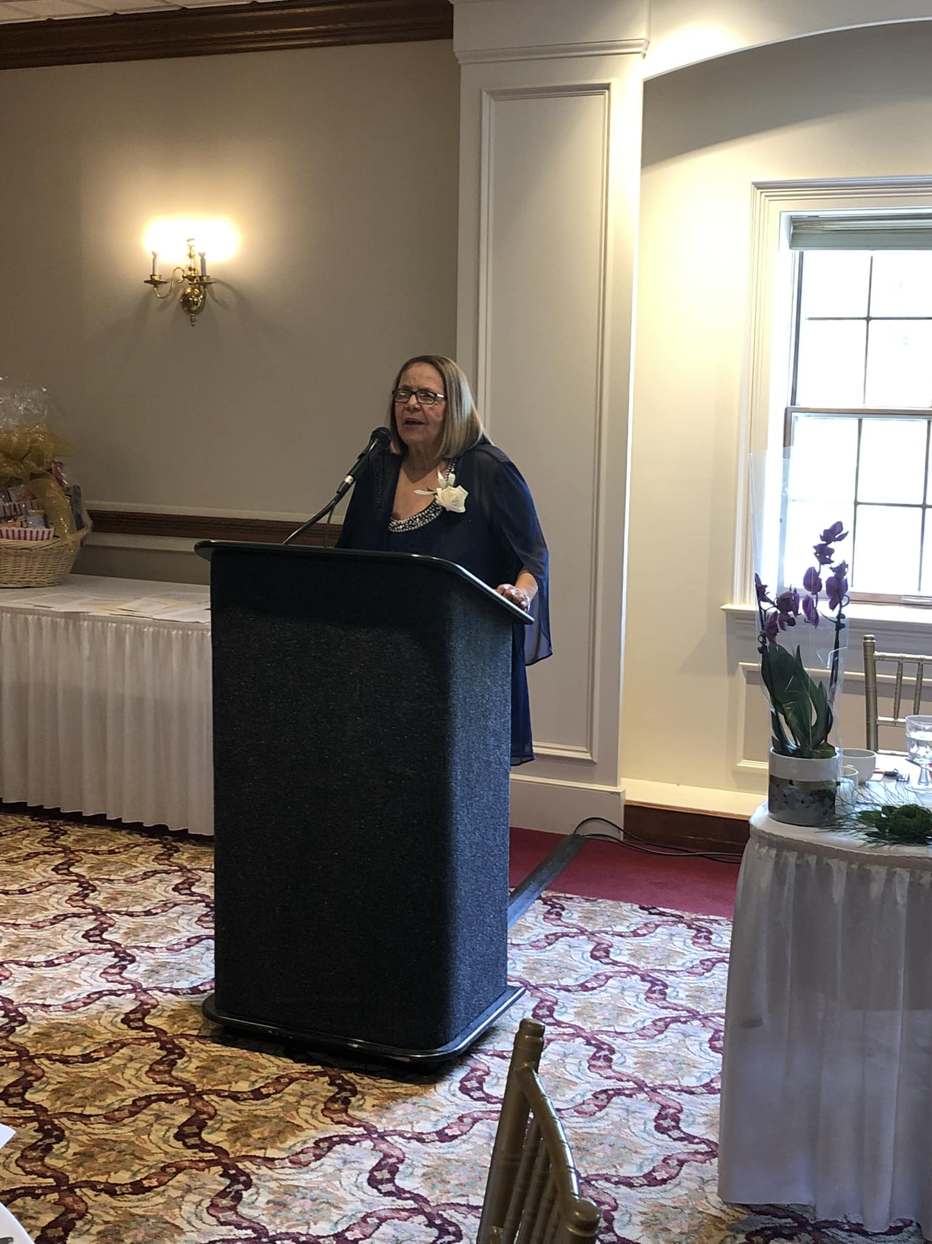

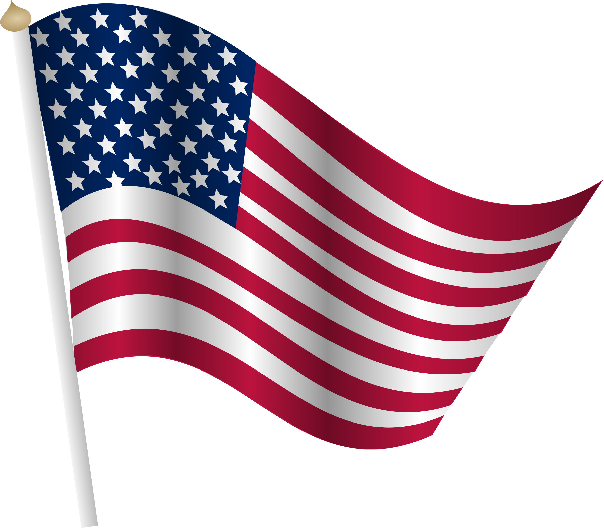Social Justice and Peacemaking News. It concerns the August 8 election on ballot initiatives making them more difficult. Early voting begins July 11. (Submitted by Stan Hirtle)
The Ohio Legislature is holding an August primary election to put forth an amendment to the Ohio Constitution, Issue 1, which would change the requirements for putting future initiative constitutional amendments on the ballot. Early voting at the Board of Elections will begin July 11 with the main special Election Day August 8. Voters must be registered by July 10 in order to vote.
In Ohio, now, and since 1912, citizens could place petitions for constitutional amendments on the ballot if they got signatures from at least 5% of voters who voted in the previous gubernatorial election in 44 of the 88 counties. Also, there was the ability to have a 10-day cure period to collect additional signatures. And when put before the people to vote, it had to have a 50%+1 approval to pass.
The amendment would change that. Future constitutional amendments would require a 60% approval by voters. The proposal would also eliminate the 10-day cure period to gather additional signatures. And it would require signatures on the petitions to have 5% of voters from EACH of the 88 counties. The effect of this is to make alternatives to the legislative process more difficult, more expensive and to increase the power of voters from smaller, more rural counties. When this is combined with the gerrymandering which has occurred in Ohio, small voter majorities become veto proof legislative majorities and supported by a small Supreme Court majority, which ruled in favor of aspects of this initiative.
If this amendment passes in August, it goes into effect immediately. Most people believe that the reason the state legislature has rushed to get it passed is to prevent an abortion rights bill from being on the ballot in November. However, it will have an ongoing effect on democracy in Ohio, affecting very many issues including gerrymandering. Very rarely does anything pass with a 60% margin, and particularly with Ohio’s mix of urban and rural counties. The signature requirements will prevent many issues from even getting there.
Proponents of the bill say this will prevent out of state interests from imposing their will on Ohio with their political donations. However, one such out of state donor gave $1.1 million dollars supporting this bill. Supporters also argue that supermajorities are appropriate to
change a constitution. Opponents say the existing system has worked well over the years and that this is an attempt to seize power at the voter’s expense.

(Social Justice & Peacemaking cont’d)
Other controversies include whether the summary of the amendment on the ballot, which is much easier to read and understand than the actual amendment, is worded more favorably than it should be, and whether such an important election should be held at an unusual time where voter turnout has been extremely low, so much so that last year the bill’s supporters sought to ban August elections.
This is a very important election since it determines what democracy will look like in Ohio for years to come, and what all the other laws will look like and stay like. Everyone should plan to vote on this issue. To determine what you think about it, study the arguments of both sides. The League of Women Voters and the Ballotpedia website are non-partisan sites that seek to summarize and clarify both sides of issues. Then go and vote. And try to get others to do the same.

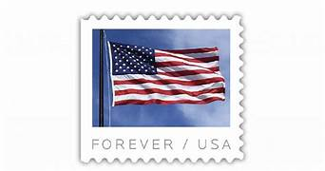SAVE YOUR STAMPS Please save your Forever Stamps and stamps with postage amount from letters received. The stamps should be cut 1/4” on each side. Stamps may be given to Gladys Turner Finney

REMINDER We continue to collect used eyeglasses, cell phones, stamps. can tabs, plastic tops/ lids and pill bottles (labels removed). We are beginning to collect old blankets and mattress covers (for sleeping bags), notepads/cards, 2024 calendars and egg cartons. NO NEED TO WASTE. Give items to Darlene Brookshire.
HAPPY BIRTHDAY!
Happy belated birthday to our June friends: Se’Kani Drake, Angel Drake, Leilani Drake, Myan Drake, Stan Hirtle, Helen Schooler, Chris Tinsley and Ivy Young
Happy birthday to our July friends: Katrina Augustin, Brenda Brown, Debra Byrd, Pam Byrd, Arianna Campuzano, Erika Dixon, Marlea Gaskins, Bruce Johnson, Jose’ Jones, Sandra March, Judy McCray, Lerone McKenzie, Brenda Thompson, and Albert Watson

