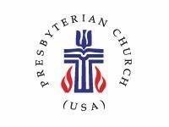 | COLLEGE HILL COMMUNITY CHURCH – PCUSA  MARCH 2024 NEWSLETTER
1547 Philadelphia Dr.  Dayton, OH 45406  (937)278-4203 | Web – collegehillcommunitychurch.org  Email - collegehillcommunitychurch@gmail.com  Church Office Open – 10am – 2pm T, W, TH
Worship: 10:30 am or on Facebook at College Hill Community Church - Dayton
Spanish translation available.

MARCH CALENDAR  March 3 – COMMUNION SUNDAY - Rev. Tinsley  March 10 - Rev. Tinsley  March 17 - Rev. Tinsley  March 24 – PALM SUNDAY - Rev. Tinsley  March 28 – MAUNDY THURSDAY  March 29 – GOOD FRIDAY  March 31 – EASTER SUNDAY – Rev/ Tinsley  One Great Hour of Sharing Collection | MARCH BIRTHDAYS  Isaac Hulbert – March 15  Ruth Bragg – March 16  Jose’ Vidal – March 19  Tamara Daniels – March 26  Nancy Garner – March 26  Fay Day – March 30  Nelson Stone Sr. - March 31

WORDS OF THANKS
The College Hill Family, Thank you so much for your prayers and support after our father’s passing. Both my mother and father were loyal members of College Hill’s family and we felt extremely supported in return. Thank you for the blessings. Angie & Johanna Griffin
Dear Members of College Hill Community Church, Our mother, Dorris Thompson, enjoyed her fellowship as a member of College Hill over the years. Thank you for the love and kindness you showed her. We are grateful for your donation and support given to our family during this time of loss. God bless you! Estelle & Donna (daughters)
Thank you for everything, Sincere thanks to everyone for your kind words, thoughts, prayers, support and love for me and Dorris’ family. Sending love back to you! Darlene Brookshire

Prayers for...Brenda Brown, Jack & Rosalyn Givens, Bruce Johnson, Nelson Stone, Frankie Weston, & our CH family. Contact the Prayer Warriors at PLtowns@msn.com

Holy Week Service and Activities Options
College Hill will celebrate both Palm/Passion Sunday on March 24 and Easter Sunday on March 31, with 10:30 am services led by Rev. Tinsley. During the remainder of Holy Week, there will not be services hosted at College Hill, but we encourage you to take part in services and activities elsewhere to deepen your experience of this journey to the cross and to resurrection.

On Maundy Thursday, March 28, starting at 6:00 pm, First Presbyterian Church in Fairborn has invited College Hill members to join them for a traditional contemplative service that includes communion. You may remember numerous years in which our two churches alternated Ash Wednesday and Maundy Thursday services. First Fairborn is at 1130 Highview Drive, Fairborn.

While the West Dayton Caravan of Churches has not released the full slate of Holy Week services as of press time for this newsletter, watch the College Hill website and Facebook page for more information soon. We have been told that St. Margaret's Episcopal Church plans both a Maundy Thursday foot washing service and a Good Friday 12 noon Stations of the Cross service. St. Margaret's is at 5301 Free Pike, Trotwood. Many area Presbyterian churches also offer Holy Week services on Thursday and Friday.

Another Good Friday, March 29, option is to participate in the Good Friday Walk for Justice and Peace, which begins at 12 noon at Courthouse Square in downtown Dayton. The walk traverses downtown locations as symbolic stations of the cross and highlights many current social justice issues and the Biblical mandate to respond. The walk in recent years has ended at First Baptist Church downtown with a soup and bread lunch offered.

Keep watching College Hill's media for more details on the many options for Holy Week

Prayer Slips Still Welcome in Worship Due to changes in the order of our Sunday service, the small square Prayer Slips you'll find in each pew should be filled out and turned into ushers during the Passing of the Peace time during the service. Those written prayer requests will then be included in the Prayers of the Congregation later in the service, along with prayers voiced with the microphone at that time. | Nursery Announcement – The nursery is available for any parent(s) who may wish to sit with their child or children. If you have a smart phone, a Bluetooth speaker is available to listen to the service while you’re in the nursery. Speak with Elder Brenda Brown with questions.

Bible Study continues on Wednesdays at 6:30 pm with Rev. Tinsley. The zoom link may be found on our FB page and our website. ALL are welcome! | Easter lilies being ordered from Oberer’s for $16.25 each. Orders will be taken until Sunday, March 17. See Kathy Lakes with your order or place your money in the offering plate with your order form.

SERVICE WORKS – by Pat Townsel
For the next several months our newsletter faith life articles will be highlighting the ministry works of our various ministry units to help us learn more about them and letting their lights shine to entice others to become more involved. Please understand that I realize “works” do not earn our salvation, which is a gift given freely, lovingly by God. However, there is an undeniable and inextricable relationship between our accepting that gift and living that gift. Consider the following scriptures:
Jesus said, “By this all people will know that you are my disciples, if you have love for one another” (John 13:35.) The way we love demonstrates who we are. The way we live is the first word we speak about the Gospel and the transformational power of the cross.”
“Let us not love in word or in tongue, but in deed and in truth” (1 John 3:18).
With the above in mind, let’s begin our look into our ministry units with the “Elam Public Relations” (EPR) which is a three-in-one unit including Outreach and Evangelism. This unit, established by and funded by a gift from deceased member James Elam seeks to spread God’s Word and other blessings by serving others and using that service as a shining example of God’s goodness, mercy, and love. Elder Brenda Peters is the chairperson and other members are Darlene Brookshire, Brenda Brown, Carole Estelle, Marlea Gaskins, Kathy Lakes, and Krista Lewis.
Like many of our ministry units, membership is not necessary to be involved. They welcome collaboration with other units or individuals. For example, one of their most recent projects was initiated by Susie Grierson, a non-committee member. Susie introduced and facilitated a connection with Pleasant Green Baptist Church. We are receiving dry goods from that church donated by Mathew 25 Ministries. Hopefully upon verifying our designation as a certified Matthew 25 Church, we will be able to obtain the donations directly. Our first donation was very well received, promising a productive, impactful, and on-going outreach ministry.
Other examples of EPR’s ministry work include an interactive relationship with Mary Scott Nursing Center, support for Rosa Parks Elementary School, our annual church parking lot flea market, financial support of community events such as the Martin Luther King Banquet, collaborating with and publicizing other ministry unit’s projects Vacation Bible School, and purchasing our church “Visitor Welcome Packets.” Please contact Chair Brenda Peters if you are planning something that needs EPR support. Remember timing is critical, so contact her well in advance.
This ministry unit is unique in that its funding is based upon the dividends from Elder Elam’s initial investment. The gift comes on condition that funds be used to help draw members into the church. Some sponsored events such as banquets may not seem to fit that agenda. However, EPR members wisely believe that community collaboration is part of making contacts and creating a positive, inviting image. They believe the “God’s love and good news are spread in a variety of ways and firmly stand on the following scripture:
Matthew 6:33 NRSV
But seek first the kingdom of God and his righteousness, and all these things will be given to you as well.
Elam Public Relations conducts an organizational meeting early in the year and meets subsequently as needed. Please contact Brenda Peters for additional information.

Bach Society plans diverse March 3 concert
On Sunday, March 3, at 4:00 pm, the Bach Society of Dayton performs “Along the Silk Road,” a collection of vocal and instrumental music from the Middle East and Asia reflecting the cultures of nations along the ancient commerce route, the Silk Road. The UD World Music Choir, the Javanese Gamelan Ensemble, Turkish music scholar and singer Latif Bolat, and UD’s Dr. Ryu-Kyung Kim join the Bach Society chorus to sing in nine languages and many musical styles. Two world premiere pieces are included. Join us for the concert on Sunday, March 3 at 4:00 pm at the Kettering Adventist Church, 3939 Stonebridge Rd., with a concert preview lecture at 3:00 pm that day. Tickets and details are at www.bachsocietyofdayton.org.
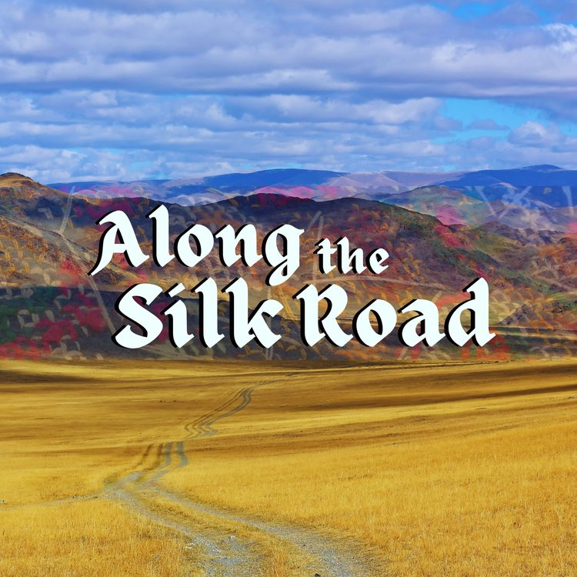

MARY SCOTT NURSING HOME GATHERING – March 19, 2024
The Elam Public Relations Ministry invites you to attend our next gathering with the residents of Mary Scott Nursing Home at Mary Scott on Campus on Tuesday, March 19, at 10:00 am. We are celebrating the first day of Spring with songs, prayers and a little fun with a Spring trivia game. College Hill will also be giving the residents a gift bag with a journal, pens, and a spring flower fidget spinner. Two staff members of Mary Scott have been bringing 5-7 residents once a month to worship with us at College Hill and are committed to continuing this for the residents who wish to attend church, and one regular attender rides the church van weekly. We celebrate this newly built relationship with the residents of Mary Scott!

Pssst! The College Hill flea market will be on August 3rd – mark your calendars.

SPECIAL EASTER OFFERING
Please give generously to One Great Hour of Sharing, a special offering collected by many denominations at Easter. For Presbyterians it supports Hunger relief through the Presbyterian Hunger Program, Disaster relief through Presbyterian Disaster Assistance, and Injustice relief through Self-Development of People. Presbyterian Hunger program works in the US and abroad so that people have sufficient money, seeds, land, water, equipment and training to feed themselves and their families. It also works to ensure everyone in the food production process is treated fairly, and to protect the environment. Presbyterian Disaster Assistance supports recovery from the many tornadoes, floods, hurricanes, wildfires, droughts and earthquakes that are recurring with more frequency in the US and the world. Relief workers from Presbyterian Disaster Assistance came to this church after the 2019 tornadoes, as they have been to many other disaster sites before and since. Self-Development of People works with low-income communities in the US and abroad to overcome oppression and injustice through projects focused on advocacy, youth-led initiatives, skills development, farming, refugee issues, and capacity building. Read more at https://specialofferings.pcusa.org/site_media/media/uploads/specialofferings/specialofferings_site/leader_guide/oghs24_leaders_guide.pdf This Offering will be taken on Easter Sunday at College Hill, but you can also give at other times using pew envelopes that will be in the racks on Sundays before and after Easter, as well as by mail or online.

To the new deacons on board,
We would like to say thank you all for serving. We also want you to know that we already love all the things that you’re going to do for College Hill. We ask the members to be patient as the deacons work together to contact our members. Our goal is for all members to be contacted by their new deacon soon. Also, members please feel free to share concerns with any deacon until we get our shepherding lists created.
From Deacons Mack and Melanie

ADDITIONAL BLACK HISTORY INFORMATION
Here are links I wanted to share from my Moment of Black History talk. I really hope it will encourage us to go to the website. So Much Information! - Carole Estelle
https://www.pcusa.org/news/2023/4/3/timeline-of-african-american-presbyterian-history/
www.presbyterianmission.org/story/
www.presbyterianmission.org/story/african-americans-have-rich-history-in-the-presbyterian-church/
https://www.presbyterianmission.org/story/presbyterian-mathematician-medal-of-honor-winner-katherine-johnson-dies-at-age-101/
MATTHEW 25 CHURCH
https://www.pc-biz.org/search/3001002
Our own local Presbytery
https://miamipresbytery.org

YOU ARE INVITED TO CELEBRATE BLACK AMERICAN CONTRIBUTIONS TO THE FAMILY OF GOD – February and Beyond 2024
Shiloh Church, United Church of Christ at 5300 Philadelphia Drive at North Main Street invites you to attend:
Friday, March 8, 2024, 6:30 pm – Gospel SongFest, Terrence Grimes, Leader
Monday, March 11, 2024, 11:30 am – 1:00 pm – Symphony of Schools Program by Dayton Public School Students -- Music, Dance, Poetry
ALL ARE WELCOME! Contact Shiloh Church at 937-277-8953 for more information.

From the Sisters of the Holy Cross -
Dear Gladys, Thank you! Your in-kind donation of canceled US and foreign stamps, which will benefit our Ministry with the Poor, has been received! Your support means so much to the people with whom the Sisters of the Holy Cross minister here at home and abroad. You are making a difference! Sister M. Rose Edward, CSC, Director of Development

(Please save your Forever Stamps and stamps with postage amount from letters received. The stamps should be cut 1/4” on each side. Stamps may be given to Gladys Turner Finney)

SAVE AND REUSE  We continue to collect used eyeglasses, cell phones, stamps. can tabs, plastic tops/ lids and pill bottles (labels removed). We are beginning to collect old blankets and mattress covers (for sleeping bags), notepads/cards, 2024 calendars and egg cartons. NO NEED TO WASTE. Give items to Darlene Brookshire. | GIVE OF YOUR TIME AND TALENTS  We ask you in 2024 to reflect and commit to ways you may volunteer your time and talent to College Hill. All the ministry units accept new committee members year-round and would love your new ideas and energy! Go to the College Hill website to see the various ministries and their descriptions.  Collegehillcommunitychurch.org

