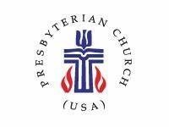 | COLLEGE HILL COMMUNITY CHURCH – PCUSA  APRIL 2024 NEWSLETTER
1547 Philadelphia Dr.  Dayton, OH 45406  (937)278-4203 | Web – collegehillcommunitychurch.org  Email - collegehillcommunitychurch@gmail.com  Church Office Open – 10am – 2pm T, W, TH
Worship: 10:30 am or on Facebook at College Hill Community Church - Dayton
Spanish translation available.

APRIL CALENDAR  April 7 – Communion Sunday  Rev. Tinsley - “Thomas answered, ‘My Lord and my God!’”  April 14 – Rev. Tinsley - “Why do doubts arise in your Hearts?”  April 21 - Rev. Jacqueline Nowak, retired minister of the Word and Sacrament in the Presbytery of the Miami Valley  April 28 – Rev. TInsley - “Everyone who loves is born of God” | APRIL BIRTHDAYS  Timothy Hueston – April 1  MackArthur Lakes III – April 1  Marjorie Baker – April 4  Josephine Laury – April 14  Krista Lewis – April 14  Daniel Peters – April 21  William Givens – April 24
SPECIAL PRAYERS
Chante’ Johnson (brother, Marcus), Gloria Gates & Michael Love, WIlliam “Jack”Givens, Lerone McKenzie (mother, Jacqueline), Nelson Stone, Brenda Brown, Kevin Lewis (sister, Krista), Bruce and Betty Johnson, and all of our members who watch from home for various reasons.
(Please contact the church office by Thursday 10am to add names to the printed prayer list.)

NEWS FROM THE ADMINISTRATIVE COMMISSION

Dear Members of College Hill Community Church,

We hope this letter finds you in good health and high spirits. We are writing to inform you about an essential development within your church community. The Miami Valley Presbytery has determined that College Hill Community Church is in schism and assigned the Administrative Commission (AC) to determine the “true church within the PCUSA.” The Presbytery remains committed to the congregation’s mission as a multicultural, Reformed Christian witness in West Dayton.
According to F-1.0303, “Where Christ is, there is the true church. Since the earliest days of the Reformation, Reformed Christians have marked the presence of the true Church wherever The Word of God is truly preached and heard, The Sacraments are rightly administered, and Ecclesiastical discipline is uprightly ministered.”

Considering this, we kindly request your participation in the decision-making process. We want to know if you wish to remain a member of CHCC and the Presbyterian Church (PCUSA). Your response will assist us in understanding the commitment and dedication of your congregation. It will help us determine the true church that will ensure your beloved church’s continued growth and stability.

According to the guidelines outlined in the Book of Order of the PCUSA, in G-1.0304 The Ministry of Members Membership in the Church of Jesus Christ is a joy and a privilege. It is also a commitment to participate in Christ’s mission to wit:

A faithful member bears witness to God’s love and grace and promises to be involved responsibly in the ministry of Christ’s Church. Such involvement includes: proclaiming the good news in word and deed, taking part in the common life and worship of a congregation, lifting one another up in prayer, mutual concern, and active support, studying Scripture and the issues of Christian faith and life, supporting the ministry of the church through the giving of money, time, and talents, demonstrating a new quality of life within and through the church, responding to God’s activity in the world through service to others, living responsibly in the personal, family, vocational, political, cultural, and social relationships of life, working in the world for peace, justice, freedom, and human fulfillment, caring for God’s creation, participating in the governing responsibilities of the church, and reviewing and evaluating regularly the integrity of one’s membership, and considering ways in which one’s participation in the worship and service of the church may be increased and made more meaningful.

We want to emphasize that CHCC is a community filled with the love of God and the Holy Spirit. We believe that together, we can continue our journey of faith and positively impact the lives of those around us. The AC prays for your continued presence and active involvement in your church family.

If you have any questions or concerns regarding this matter, please do not hesitate to contact us. Your input is valuable; we want to hear everyone's voice. Thank you for your attention to this critical matter. We appreciate your dedication to CHCC and the PCUSA. Let us continue to walk hand in hand as we navigate the path ahead, guided by the love of God.

Blessings,

The Administrative Commission

Save the Date! May 4
On Saturday May 4 from 11:00-2:00, College Hill Community Church will have a day retreat in the Fellowship Hall. We will have a congregational meeting to receive the annual report and provide some opportunities for both spiritual nurture and equipping leaders. The AC will provide lunch. We look forward to seeing you at this important event!

Also, minister unit leaders should submit their annual reports to the church office by April 15.

The Administrative Commission

CHCC Older Kids Ministry - Loss/Resiliency Seminar
June 27, 2024
10:00 AM-2:00 PM
CHCC Fellowship Hall
The year 2023 was a year of significant changes in the life of College Hill Community Church, PCUSA. Members of all ages are invited to come together to talk about the changes, their impact, past and present, individually and collectively and how the concept of resilience can help us move forward together and thrive!
There are two components of Resilience: the ability to protect one’s self-esteem under pressure and the ability to construct a positive life in spite of difficult circumstances. “Everyone young and old, needs to develop resilience.”
Gladys Turner Finney, Chair
Older Kids

Jeremiah 29 :11 “For I know the plans I have for you,” declares the Lord, “plans to prosper you and not to harm you, plans to give you hope and a future.”

FAITH LIFE: Buildings and Grounds—
Headache or Headache Antidote? by Pat Townsel

The Building and Grounds Ministering Unit (B&G) is responsible for ensuring a physical environment conducive to effective worship and fellowship for members and friends of the church and for community groups. This is a huge responsibility which includes ensuring the proper functioning of the building itself, the furnishings, equipment, grounds, safety systems, and vehicles. As you can imagine, this demands a great deal of time, labor, thought, planning and prayerful cooperation. Our congregation can be sure current chair Dan Peters, and other members Darlene Brookshire, Marlea Gaskins, Mack Lakes, and Helen Schooler happily, work cooperatively and tirelessly to meet the unit’s purposes. They often are first to be in the church, the last to leave, and at the church for more times than Sunday services and Wednesday Bible Study. Furthermore, they may have to be available to do the same thing during the week for funeral services, outside community group meetings, or even any time of the day alarm is triggered. They do all this for a very familiar motive- using their personal gifts in service for their love of church and God.
When asked the question about the biggest challenge, Dan replied that it is the balancing act of trying to meet the unit’s goal in a time of an aging building, increased costs for labor and material goods and services and increased members and friends of the congregation on fixed incomes. Fortunately, some committee members have skills and knowledge to do repairs. Others have an interest in maintaining and beautifying the grounds. Some have both. Additionally, several non-committee members volunteer to help by straightening the sanctuary following services or replacing donation envelopes and pens in the pews. Others volunteer to help with major cleaning projects. The committee extends their deep gratitude for this assistance. Perhaps this article will help you to think of a way you can help in addition to how you automatically act with care for our church and our church grounds. Please remember the committee is very welcoming to anyone who wishes to become a member. The meetings are monthly on the 2nd Wednesday at 1:00 PM. Simply contact the chair or any member listed above.
Despite the enormity of the responsibility all the members are sustained by their love and commitment in serving God through their gifts of themselves to the church they love. They are a committee that has no choice but to deal with the past, present, and future simultaneously. Structures formed in the past impact what will or will not work for today. The structures of today hopefully will be such they will carry usefully through into the future. It seems Buildings and Grounds has a rather unique ability to use work of the day to change the past and impact the future all at the same time. Yes! what a responsibility, but also what a stimulating and vision-filled opportunity! No wonder the committee deals with frustration, gratification, optimism, hope and trust. If you had to guess, which of those feelings has the most influence? I’ll give you a hint. Most of the members have enjoyed continued volunteer service for several years! You should be able to find the right answer( s) very easily.

Immersion Baptism Pool Removed. Why?
The combination indoor immersion baptismal pool/communion table has been removed from the church and replaced by the former communion table. Why has this happened?
The church had an immersion pool constructed several years ago, but it was controversial. One reason was cost, and the other reason was the concern expressed about the method of baptism in churches like ours. Baptism by immersion is not new in Presbyterian churches and is one of several ways that the Book of Order allows PC (U.S.A.) churches to carry out baptisms. For many, immersion can be considered a common practice compared to others.
Recently church leaders were informed that the church had never fully paid for the construction and installation of this new addition to the sanctuary, and there was a balance due of $2,500. Considering the original controversy and after reviewing all options, we are grateful that the company that owned the baptismal pool agreed to take the immersion pool/communion table back without requiring us to pay the remaining costs, although also without refunding the money the church had paid earlier.
Church leaders agreed that the former communion table and the long-standing baptismal font, both in the front of the sanctuary and smaller than the one replaced, would serve our church’s needs. Should anyone in the future desire to be baptized by immersion, we have alternative ways to accomplish that sacrament that has worked in the past.
This removal decision is considered a part of the process of moving forward as a church community toward a more unified, faithful future in Christ’s service.

PRODUCTS SHARED  Our Matthew 25 Sharing will not be held in April perhaps due to a greater sharing need because of the recent tornados in Ohio. You may have seen the huge Matthew 25 Ministries semis loaded with products for the devasted communities. We are only too happy to be participating in this way. Our prayers are with those suffering people. WE will inform you if we are able to participate in our regular form of sharing in May. Thank you for your understanding. | SAVE AND REUSE  We continue to collect used eyeglasses, cell phones, stamps. can tabs, plastic tops/ lids and pill bottles (labels removed). We are beginning to collect old blankets and mattress covers (for sleeping bags), notepads/cards, 2024 calendars and egg cartons. NO NEED TO WASTE. Give items to Darlene Brookshire.

SOCIAL JUSTICE & PEACEMAKING MINISTRY PLAN CHURCH DISCUSSION
By Stan Hirtle, chair
For several years, College Hill church has erected and maintained crosses on the church grounds commemorating African Americans killed by police under questionable circumstances. The crosses refer to the Black Lives Matter (BLM) movement protesting police treatment of black people by “saying their names” and seeking police reforms. The crosses contain well-known names such as George Floyd, Breanna Taylor, Tamir Rice, Freddie Gray, Michael Brown and Eric Gardner, as well as lesser-known names.
The action was initiated by our former pastor and supported by the Social Justice and Peacemaking Ministry. Crosses were donated by a friend of the church and painted and installed by church members. Over the years some of these crosses have been removed or damaged by unknown persons, and all have had the paint worn by the elements and by lawn care. Social Justice and Peacemaking is asking what should happen now and is seeking the input of the whole congregation as to what should be done concerning the crosses.
To make the crosses respectable and fill the gaps we would probably want to add around 6-8 new crosses and repaint the old ones. Unfortunately, the problem has not gone away. There have been continued police killings of Blacks under questionable circumstances, giving us many more names to choose from.https://en.wikipedia.org/wiki/List_of_unarmed_African_Americans_killed_by_law_enforcement_officers_in_the_United_States
Social Justice and Peacemaking wants to hear from the church about what Social Justice actions they want the church to take. In particular what you think should happen concerning the signs. We plan to hold a meeting after church soon to give everyone a chance to express their feelings. And if you cannot attend, let someone in Social Justice and Peacemaking know your thoughts.

Bach Society Offers Mozart’s Great Mass in C Minor
On Mother’s Day, Sunday, May 12, at 4:00 pm, the Bach Society of Dayton presents one of the greatest works of Wolfgang Amadeus Mozart, the Mass in C Minor, at the Kettering Adventist Church, 3939 Stonebridge Road. The Bach Society chorus (including our own Larry Hollar), joined by soloists Minnita Daniel-Cox, Andrea Chenoweth Wells, Daniel Weeks, and Kenneth Shaw, and professional orchestra led by concertmaster Youjin Na, will perform this revered, sacred masterpiece.
Two special events accompany the concert. A formal tea to celebrate Mother’s Day will be served at 1:00 pm in an elegant and seated setting with tea sandwiches and pastries. In addition, a Concert Preview lecture at 3:00 pm (one hour before the concert) at the Adventist Church will feature Neal Gittleman, Artistic Director and Conductor of the Dayton Philharmonic.
For more information or to order tickets to the May 12 concert or the Mother’s Day Tea, click on https://bachsocietyofdayton.org/concerts.

Good Friday Walk for Justice and Peace
Stan Hirtle and Larry Hollar represented College Hill at the annual noontime Good Friday Walk for Justice and Peace on March 29, an annual Holy Week journey through downtown Dayton that lifts many social justice issues for awareness and response. This year’s issues included executions, gun violence, hunger and homelessness, mental health, education, world peace, anti-racism, immigration and refugees, domestic violence, LGBTQI+ concern, infant mortality, lack of affordable childcare, environmental justice, and the stale response of the Church. Representatives from Dayton-area organizations dealing with these issues spoke at each of the 14 stations of the cross at which the walkers stopped. College Hill is one of 19 sponsors of the Walk.

Hi Larry,

It was such a blessing worship with FPC and CHCC friends last night. I have posted the service on the YouTube channel we use for worship videos. The link is below for sharing in any way you please.

With Good Friday blessings.
Rev. Joe Hinds
First Presbyterian Church
https://youtu.be/NC2o6UuDLxk

Home Communion Training for Elders and Deacons
Monday, April 15th, 6pm
College Hill Church Fellowship Hall

Rev. Cynthia Holder-Rich will be leading a training session to better equip us to provide home communion to our members who are unable to join us in person for worship on Sundays. All ordained elders and deacons are welcome -- regardless of whether you are currently serving in that capacity. If you have questions or need more information, please call Melanie Monzon at (937) 510-8978

Deacon Update
We had a great first meeting and training session! We are so grateful to God for providing such a fantastic and diverse team of deacons to serve alongside us. We also want to acknowledge Kathy Lakes for her incredibly generous and diligent efforts to update the Deacon Handbook and prepare the materials needed for our first meeting. She really saved us!

Mack Lakes and Melanie Monzon were elected to serve as Co-Moderators for 2024 and Obie Harris was elected to serve as Secretary. We are especially thankful to Obie for stepping up to fill that critical role. We are also grateful to the session for responding so positively to our requests for home communion training and to re-affirm the escalation process we established last fall to get members pastoral care, as needed.

We are still in the process of configuring the shepherding assignments, pending some updates from the session regarding the membership list. However, most members now have an assigned deacon. You should be hearing from your new deacon this month, if they have not already reached out to you.

If you don't know who your assigned deacon is or you have an urgent situation and are in need of pastoral care, please call Deacon Melanie Monzon at (937) 510-8978 or Deacon Mack Lakes at (586) 488-8712.

Submitted by Mack Lakes & Melanie Monzon, Co-Moderators of the Deacon Board

KROGER REWARDS HELP COLLEGE HILL
Have you signed up for College Hill Community Church to receive rewards from the shopping you do at Kroger? If not, please read this. Every quarter College Hill receives a check from Kroger for about $60.00 from the 15 or so people who have signed up. It doesn’t cost you anything-you still get your gasoline credits and any coupons you have signed up to use.
It’s easy to sign up. Go to Kroger.com/communityrewards and follow the instructions. If you need help, contact Paula Ewers through the church office at 937-278-4203 and she will walk you through it.

Twenty-eight years and counting!
By Jose’ Lamont Jones
The 2024 Celebration of Black History continued a twenty-eight-year tradition at our sister denomination; Shiloh UCC. Mrs. Terry Ogletree, a long-time friend of College Hill Community Church, has done it again. This year’s program featured a visit from Talladega College President, Dr. Gregory J. Vincent and the College Choir to motivate and recruit students to use their talents to achieve and strive for educational advancement.
Talladega College is a Historically Black College and University (HBCU) located in Talladega, Alabama. The College has a unique origin story in that it is the only U.S. College built, brought and dedicated to education by two formerly enslaved persons. The College continues this legacy of education as it sends 80% of its graduates on to professional and graduate programs around the country!
Not only were the educational exploits of the college featured but also the talents of its choir. Their display was an excellent backdrop for the featuring of local schools who also showed how they are developing students in music. Various elementary schools, Stiver’s HS Choral group and the Belmont HS Band showed how the Dayton schools are developing local talent.
Additionally, there were many businesses and groups, which presented displays of artwork, history and their businesses for all to see. Among them was our own Gladys Turner-Finney who presented a display on the ESPER (Ebony Society of Philatelic Events and Reflections) movement to petition for African American historical figures acceptance for collectible stamps. She also featured information on her efforts to enlighten the world about the contributions of Ohio born- Professor Joseph Carter Corbin, founder of what is now the University of Arkansas, Pine Bluff.
Let us be intentional about teaching how the history of all cultures in America are an integral part of American History…especially in today’s society! In addition, let us support those that do. We owe it to our future generations.
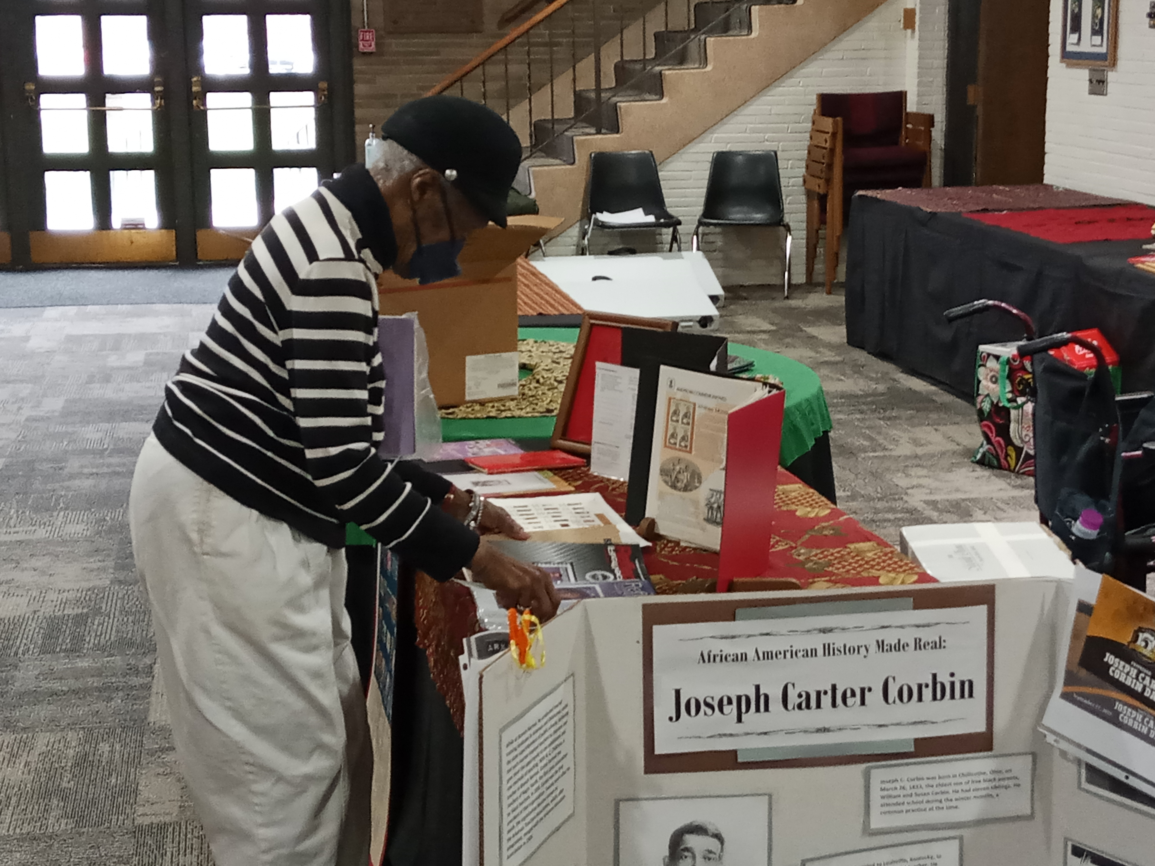
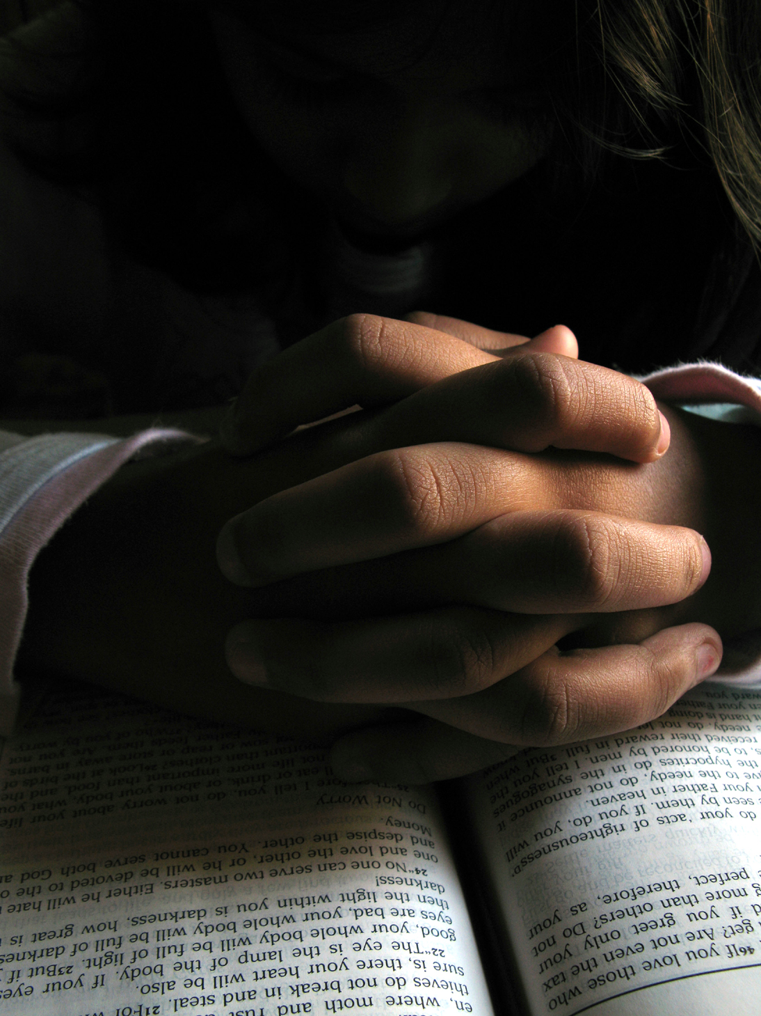Prayer List Updates:

Prayers for Jose Vidal for more gainful, full-time employment .
General prayers for the Monzon family
General prayers for the Zagal family
Prayers for Ismael Jimenez that he will get access to the medical care he needs so he can get back on his feet.
Prayers for Martha Saavedra seeking better employment opportunities

Dear College Hill Family,
You may have noticed that my worship attendance has been sporadic lately. The issue is that I am no longer able to drive due to some pretty serious visual impairment issues. The good news is that there is strong hope that my vision will be restored at least sufficiently to be able to drive again, if not fully. It's just uncertain how long that will take. As always, your prayers are appreciated. I am tremendously grateful to Larry, Mack and Marcus, who have all pitched in from time to time to get me to and from church when they are able. However, their availability is limited.
Because I live in Xenia, it is impractical for the church van to pick me up. So, I am humbly asking for your help, church family.
My prayerful hope is that a small group of College Hill members would step forward to come alongside me by being willing to provide a ride to and/or from church on an occasional basis - particularly at times when my presence is most needed.
It would not necessarily need to be both directions, and I hope by having a handful of folks willing to pitch in from time to time, no one would feel burdened. The most critical need is for a ride from my house to College Hill because Uber and Lyft coverage is very spotty and unreliable in Xenia - especially on Sunday mornings.

It's almost exactly 20 miles (25 - 30 minutes, depending on traffic) from my house to College Hill, and I will happily pitch in for gas if that is helpful. If you are willing to be added to my contact list of folks willing to provide an occasional ride, please call me at (937) 510-8978.
Blessings and thanks,
Melanie

Black Women’s Health Initiative Conference – May 4, 2024
Mt Enon Family Life Center – 1501 W. Third St.
11am – 3pm
More details at 937-241-0965
`

